TABLE DEFINITION AND CONTENT

**USER TABLE**

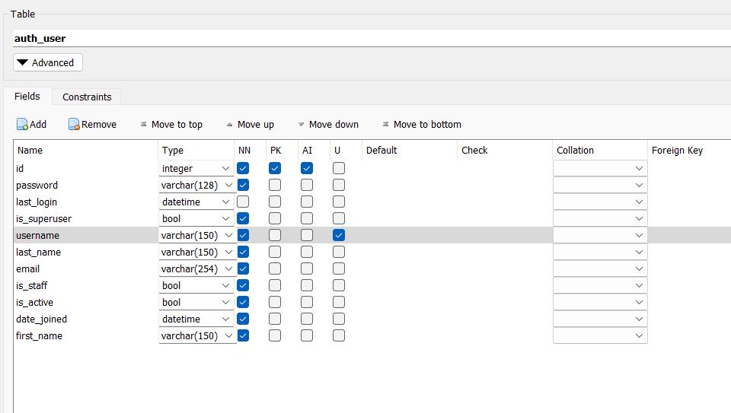



**STUDENT TABLE**

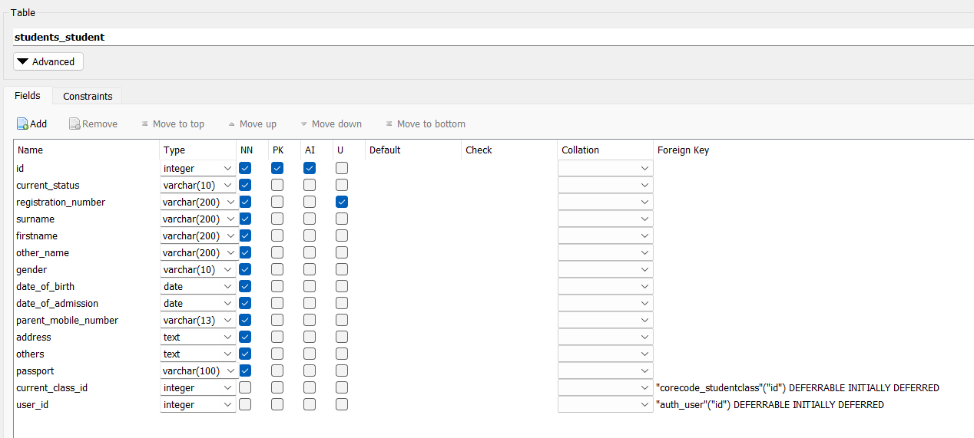



**TEACHER TABLE**

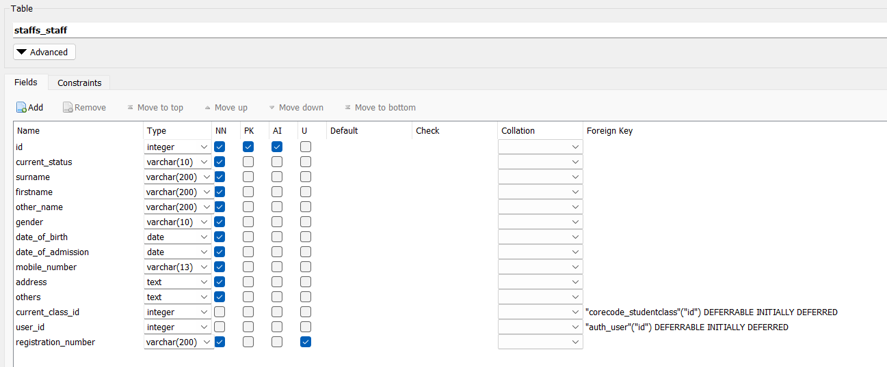



**CLASS TABLE**

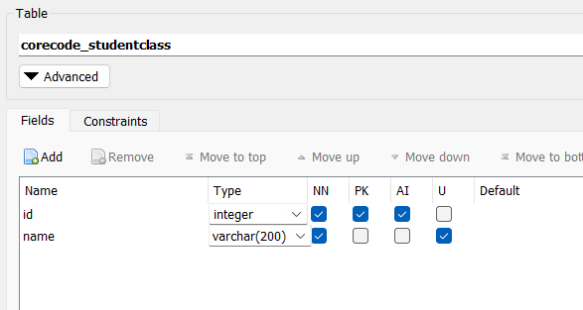

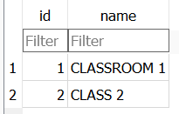

**SUBJECT TABLE**

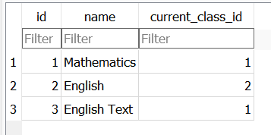

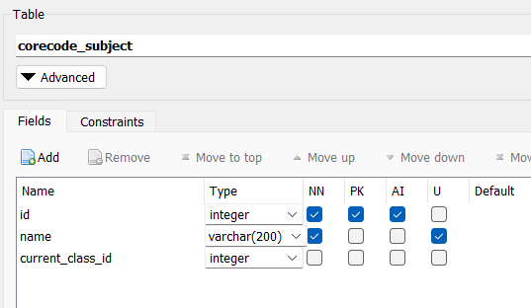

**RESULT TABLE**

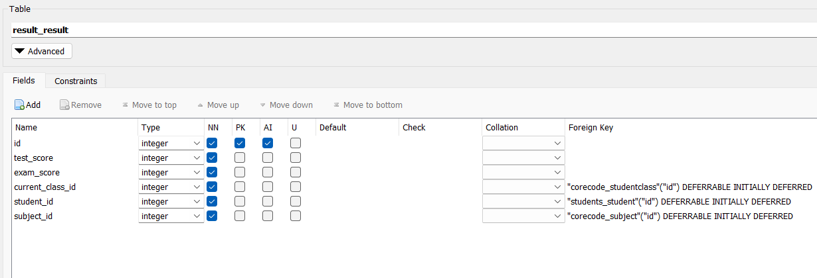

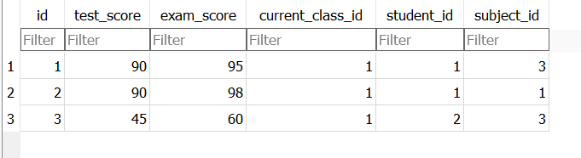

**CONFIG TABLE**

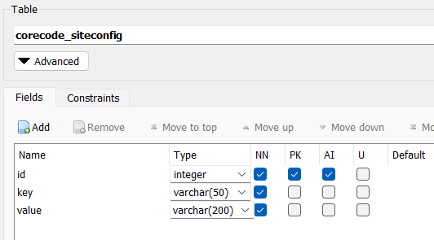

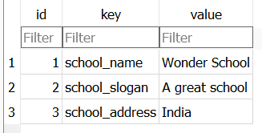

PHYSICAL DESIGN

**USER TABLE**

CREATE TABLE "auth_user" (

"id" integer NOT NULL,

"password" varchar(128) NOT NULL,

"last_login" datetime,

"is_superuser" bool NOT NULL,

"username" varchar(150) NOT NULL UNIQUE,

"last_name" varchar(150) NOT NULL,

"email" varchar(254) NOT NULL,

"is_staff" bool NOT NULL,

"is_active" bool NOT NULL,

"date_joined" datetime NOT NULL,

"first_name" varchar(150) NOT NULL,

PRIMARY KEY("id" AUTOINCREMENT)

);

**STUDENT TABLE**

CREATE TABLE "students_student" (

"id" integer NOT NULL,

"current_status" varchar(10) NOT NULL,

"registration_number" varchar(200) NOT NULL UNIQUE,

"surname" varchar(200) NOT NULL,

"firstname" varchar(200) NOT NULL,

"other_name" varchar(200) NOT NULL,

"gender" varchar(10) NOT NULL,

"date_of_birth" date NOT NULL,

"date_of_admission" date NOT NULL,

"parent_mobile_number" varchar(13) NOT NULL,

"address" text NOT NULL,

"others" text NOT NULL,

"passport" varchar(100) NOT NULL,

"current_class_id" integer,

"user_id" integer,

FOREIGN KEY("current_class_id") REFERENCES "corecode_studentclass"("id") DEFERRABLE INITIALLY DEFERRED,

FOREIGN KEY("user_id") REFERENCES "auth_user"("id") DEFERRABLE INITIALLY DEFERRED,

PRIMARY KEY("id" AUTOINCREMENT)

);

**TEACHER TABLE**

CREATE TABLE "staffs_staff" (

"id" integer NOT NULL,

"current_status" varchar(10) NOT NULL,

"surname" varchar(200) NOT NULL,

"firstname" varchar(200) NOT NULL,

"other_name" varchar(200) NOT NULL,

"gender" varchar(10) NOT NULL,

"date_of_birth" date NOT NULL,

"date_of_admission" date NOT NULL,

"mobile_number" varchar(13) NOT NULL,

"address" text NOT NULL,

"others" text NOT NULL,

"current_class_id" integer,

"user_id" integer,

"registration_number" varchar(200) NOT NULL UNIQUE,

PRIMARY KEY("id" AUTOINCREMENT),

FOREIGN KEY("current_class_id") REFERENCES "corecode_studentclass"("id") DEFERRABLE INITIALLY DEFERRED,

FOREIGN KEY("user_id") REFERENCES "auth_user"("id") DEFERRABLE INITIALLY DEFERRED

);

**SUBJECT TABLE**

CREATE TABLE "corecode_subject" (

"id" integer NOT NULL,

"name" varchar(200) NOT NULL UNIQUE,

"current_class_id" integer,

PRIMARY KEY("id" AUTOINCREMENT),

FOREIGN KEY("current_class_id") REFERENCES "corecode_studentclass"("id") DEFERRABLE INITIALLY DEFERRED

);

**RESULT TABLE**

CREATE TABLE "result_result" (

"id" integer NOT NULL,

"test_score" integer NOT NULL,

"exam_score" integer NOT NULL,

"current_class_id" integer NOT NULL,

"student_id" integer NOT NULL,

"subject_id" integer NOT NULL,

FOREIGN KEY("subject_id") REFERENCES "corecode_subject"("id") DEFERRABLE INITIALLY DEFERRED,

FOREIGN KEY("student_id") REFERENCES "students_student"("id") DEFERRABLE INITIALLY DEFERRED,

FOREIGN KEY("current_class_id") REFERENCES "corecode_studentclass"("id") DEFERRABLE INITIALLY DEFERRED,

PRIMARY KEY("id" AUTOINCREMENT)

);

**CONFIG TABLE**

CREATE TABLE "corecode_siteconfig" (

"id" integer NOT NULL,

"key" varchar(50) NOT NULL,

"value" varchar(200) NOT NULL,

PRIMARY KEY("id" AUTOINCREMENT)

);